press release
(English translation)

INOUT 2024 LAYOUT AND SERVICES
www.inoutexpo.it

Rimini, 9-11 October 2024 - The layout and services of the InOut|The Contract Community (Rimini Expo Centre, 9-11 October 2024) merge with those of the parallel event TTG Travel Experience, both organized by Italian Exhibition Group.

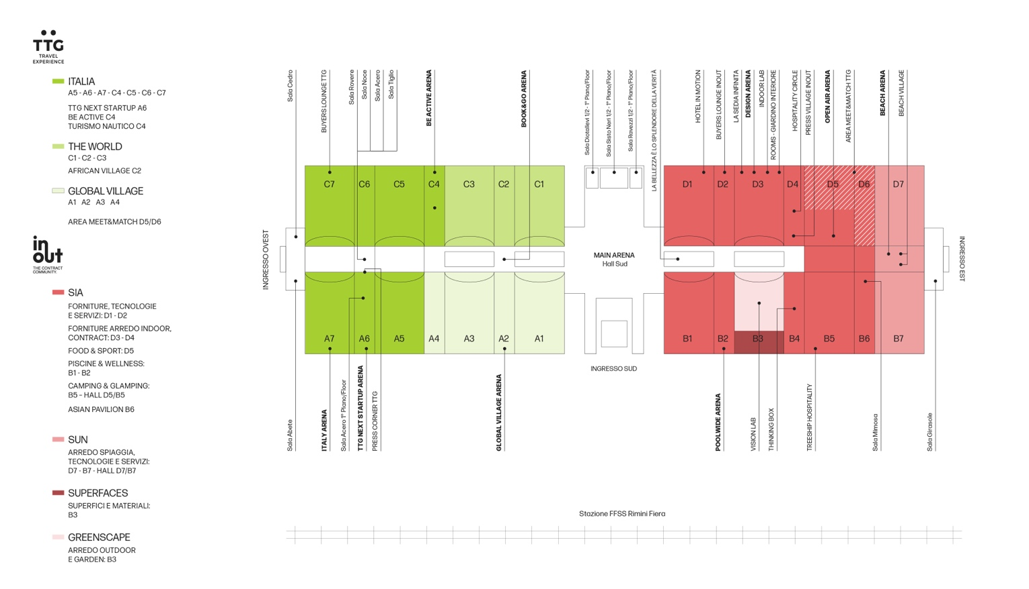
InOut|The Contract Community occupies 14 pavilions in the East wing of Rimini Expo Centre. Entrance possible either from the south, passing through the Main Arena that divides InOut from TTG Travel Experience, or from the East entrance, directly in front of the Beach Village and its Beach Arena. Pavilions D1, D2, D3, D4, part of D5 in addition to B1, B2, B4, B5 and B6 house the SIA Hospitality Design exhibition space.
SUN Beach&Outdoor Style occupies pavilions D7 and B7, while Greenscape and Superfaces share B3. As for the special projects, The Infinite Chair is in D3 with the Indoor Lab and Rooms-Interior Garden; the Hospitality Circle is in D4 (together with the InOut press village) whereas the Beach Village is between pavilions D7 and B7. Lastly, Hall B5 hosts Treeship Hospitality and B3 for the Vision Lab.
Moving on to the arenas, the Design Arena is in Hall D3, the Open Air in Hall D5, the Poolwide Arena in B2 and finally, the Beach Arena between Halls B7 and D7.

Opening hours will be identical to TTG Travel Experience: Wednesday 9 October from 10 am to 6 pm, Thursday 10 October from 10 am to 6 pm, and Friday 11 October from 10 am to 5:30 pm.

There are several transport solutions for getting to the Expo Centre – car, train, plane and sustainable mobility: all options can be found at this link.

ABOUT TTG TRAVEL EXPERIENCE
Event: international trade show; organizer: Italian Exhibition Group SpA; recurrence: annual; edition: 61st; open to: reserved exclusively for trade professionals; website: www.ttgexpo.it - #ttgexpo
PRESS CONTACT IEG, TTG TRAVEL EXPERIENCE
Elisabetta Vitali, head of corporate communication & media relation; Marco Forcellini, Pier Francesco Bellini, press office manager
media@iegexpo.it

MEDIA AGENCY TTG TRAVEL EXPERIENCE
Martina Vacca: martina@mindthepop.it, mob. +39 339 748 4994; Fabrizio Raimondi: fabrizio@mindthepop.it, mob. +39 335 389 848; Benedetto Colli: benedetto@mindthepop.it, mob. 380 371 2272; Stefano Chiossi: stefano@mindthepop.it, mob. + 39 388 739 4358.

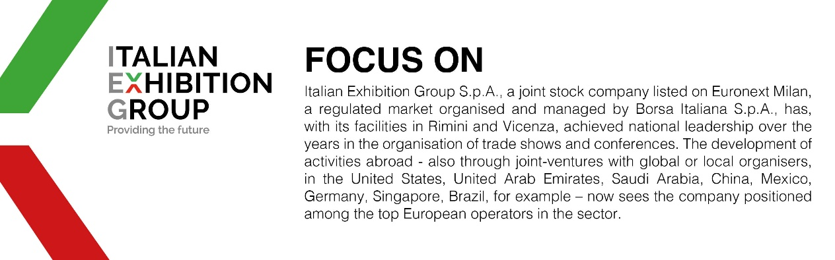

This press release contains forecast elements and estimates that reflect the management’s current opinions (“forward-looking statements”), particularly regarding future management performance, realization of investments, cash flow trends and the evolution of the financial structure. For their very nature, forward-looking statements have a component of risk and uncertainty, as they depend on the occurrence of future events. The effective results may differ (even significantly) from those announced, due to numerous factors, including, only by way of example: food service market and tourist flow trends in Italy, gold and jewellery market trends, green economy market trends; the evolution of raw material prices; general macroeconomic conditions; geopolitical factors and evolutions in the legislative framework. Moreover, the information contained in this release does not claim to be complete, and has not been verified by independent third parties. Forecasts, estimates and objectives contained herein are based on the information available to the Company as at the date of this release.

